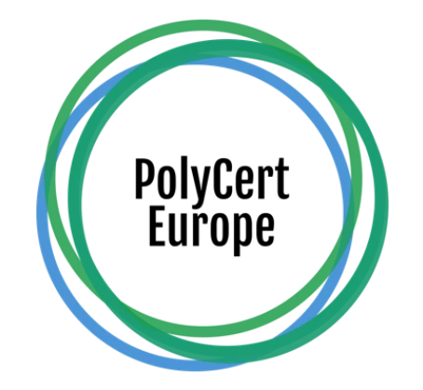

**NEWS RELEASE**

**FOR IMMEDIATE RELEASE**

**PolyCert Europe**

26 January 2022

**PolyCert Europe Launches New Website**

**Belgium, Brussels, January 26, 2022**. PolyCert Europe, a platform bringing together existing national certification schemes in a comprehensive system for polymer converters, is thrilled to announce the launch of its new website at [www.polycerteurope.eu](http://www.polycerteurope.eu). The certification schemes under the PolyCert Europe umbrella have been helping companies to certify recycled content in their products and to ensure compliance with respective national requirements. Its new website will provide more valuable information to better serve this purpose.

The site now features several new additional sections: In “Certification schemes” you will find an overview of all the certification schemes under the umbrella of PolyCert Europe, i.e. QA-CER, AENOR, Plastics Seconda Vita and Wertstoff PET (RAL). The “Accredited certification bodies” host the profiles of and links to the accredited certification bodies who conduct audits for the respective certification schemes. Namely, Belgian Quality Association, AENOR, Kiwa and Italian Plastics Institute. Also, there is a dedicated section listing all companies across Europe and beyond which have been certified by the certification schemes of PolyCert Europe.

“*The new PolyCert Europe website will provide a great visibility to all certification schemes under the umbrella of PolyCert Europe. Companies across Europe interested in certification of recycled content in their products now have an excellent gateway to the existing certification schemes*”, said Jan Laperre, the Chairman of PolyCert Europe.

PolyCert Europe has invited visitors to explore the new website.

**About PolyCert Europe**

PolyCert Europe is an umbrella compliance scheme harmonising existing certification schemes for converters of polymeric materials in Europe. The objective of PolyCert Europe is to provide quality certification and verification of recycled content in converted products.

Top of Form

Bottom of Form

**Contact:**

Martin Policar

[info@polycerteurope.eu](mailto:info@polycerteurope.eu)